HUM

Presentation

Choix techniques et inspiration.

Description technique

Quelques repères:
Judge: partie du projet HUM qui s'occupe du traitement vidéo en général
Mind: partie du judge qui retraite l'information instantanée rendue par les analyseurs
Wanalyser: analyseur webcam
Manalyser: analyseur Quicktime Movie
Cellsgroup: nom des blobs dans les analyseurs
OSC java: formatage des paquets OSC pour java
OSC simple: formatage des paquets OSC pour Max/MSP ou PureData

Analyseur vidéo.
Deux options sont présentées au lancement du Judge: webcam ou movie.
L'analyse se fait de toute façon en temps réel, mais la source est différente.
Dans le cas d'un movie, le démarrage requiert la sélection d'une image (image de référence) et d'un fichier QT.

Fonctionnement de l'analyse.
Que ce soit pour le W- ou le Manalyser, le système d'analyse est identique. Il est diviser en 4 étapes:
- comparaison de l'image courante à l'image de référence (l'opération de création de cette image de référence est appelée « white balance »);
- dans le même temps, les pixels sont groupés par cellule sur une grille recouvrant toute l'image;
- une fois tous les pixels « actifs » groupés en cellules, ces cellules sont regroupées en Cellsgroup;
- les Cellsgroups sont ensuite comparés à ceux de l'opération précédente.

Details of each step:

STEP 1: Comparaison

The reference image and the current image are represented as an array of pixels, each pixels having three value: red, green and blue.
In the Judge interface, a slider named « sensibility » defines the amount of difference required to say that a pixel is différent from the reference' one.
The operation applied to compare two pixels is:
- is the absolute difference between the current pixel red or green or blue value and the reference pixel red or green or blue is bigger then the sensibility
- is the absolute the addition of two differences (red+green for instance) is bigger then the sensibility
If at least one of these conditions is true, the the pixel is considered as active. This implies the activation of the second step.

STEP 2: Cells

The image is virtually covered by a grid.
When an active pixel is detected, it is placed in one of the cells of this grid.
A cell is not an array of pixels:
- It has a short memory (several frames) used to smooth the occupation. The occupation of one cell is a division of the number of pixels it contains on the size of the cell.
The short term memory is a way to know if the cell is getting more or less active, depending on the rise of the diminution of pixels' number.
- It contains also the position x & y of the extreme pixels (top, right, bottom and left).
- It obviously contains the information of the current occupation of the cell.
- The average red, green and blue value of the pixels.
Once last pixel is compared, the application jumps to step 3.

STEP 3: Grouping

To start a group, there must be at least one pixel in the cell. Once the group is setup, any cells containing pixels or still active (due to to smothing, a cell can be active even if it is empty!) can respond positively to the test explained here below.
Starting with the most active cell, the grouping function search around the current cell if there are other not empty cells next to it. There are 8 possible positions: above, sharing right-top corner, right, sharing right-bottom corner, bottom, sharing left-bottom corner, left and sharing left-top corner. The analysis is made in this order, each position represented by a letter from A to H. If it finds some, it stores the cells in Cellsgroup. Once no more cells are found in the neighboorhoud of all the cells stored in a Cellsgroup, the group is closed and, if it remains active cells, the function declares a new Cellsgroup.
The Cellsgroup itself contains average of the features of each cells and the extreme points (the extreme point at the top is given by the highest pixel of all the cell in the highest row.

List of feature stored in a Cellsgroup:
- cgid
id of the Cellsgroup
- box/center/x
- box/center/y
position of the center of the bounding box
- box/top
- box/right
- box/bottom
- box/left
- box/top/x
- box/top/y
- box/right/x
- box/right/y
- box/bottom/x
- box/bottom/y
- box/left/x
- box/left/y
position of the extreme points
- barycenter/x
- barycenter/y
position of the weight center
- barycenterP/x
- barycenterP/y
position of the weight center of the cells that getting more active
- barycenterN/x
- barycenterN/y
position of the weight center of the cells that getting less active
- occupation
division of sum of cells' occupation on the total area
- occupationP
division of sum of rising cells' occupation on the total area
- occupationN
division of sum of dying cells' occupation on the total area
- numOfCells
- numOfPixels
obvious
- lifetime
Number of frame
- red
- green
- blue
rendered between 0 and 1

The interface propose two configuration for this operation: Maximum number of Cellsgroups and minimum size of Cellsgroups.
The maximum number of Cellsgroups, once reached, stops the analysis.
The minimum size of Cellsgroups implies that, if the Cellsgroup contains less cells then the number, the Cellsgroup is not saved.

STEP 4: Mapping Cellsgroups with former Cellsgroups

At the begin of the step 3, the previous Cellsgroups are saved. Once the cells' grouping finished, the new Cellsgroups are compared to the former ones. The mapping is done on basis of the distance of each borders and of the center.
The Cellsgroup id is adapted and the lifetime of the Cellsgroup incremented.

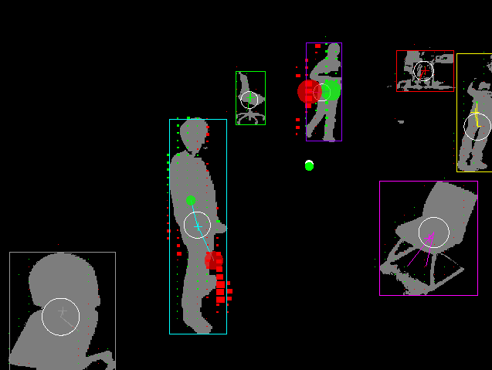
Example of a analysis

Once these four steps done, the W- or Manalyser warn the Judge that the process is finished.

Mind.

When the judge receive the signal from the W- or Manalyser that the process is finished for the current frame, it update the Mind.
The Mind is a logical part that only apply a set of operations on the results coming in. It gather automatically the features sent by the W- or Manalyser and store them per Cellsgroup. The object used to do so is an EntityTracker. Each time the Mind is updated, it checks if there's already an EntityTracker for the detected Cellsgroup, update if positive or create a new EntityTracker. The id of the EntityTracke doesn't match the Cellsgroup's one, we will see why.
All features received form the W- or Manalyser are called « natural ».
All features calculated in the EntityTarcker are calles « custom ».
Each feature is stored in an object called FeatureTracker. By default, a FeatureTracker returns the current value, the previous one, the speed and knowns if the feature is an angle.
The angle detection is based on the name of the feature. If it contains « theta » or « angl », the boolean angl is set to true.
If it's configured, each FeatureTracker can handle an Histogram or an Historic.

Specifications of an EntityTracker:
- Histogram
- Historic
- calculation of extra features
- detection of merge & split of Cellsgroups
- detection of behaviour

SPEC 1, Histogram
This object is a standard histogram, storing the value in slots between a minimum and a maximum value.
It returns the min & max value, the mean & the number of values stored.

SPEC 2, Historic
This object stores the values in a queue. Once the queue reachs the maximum of values, it drops the oldest one. Historic returns median, mean, max & min value. It considers the boolean « angl » from its FeatureTracker to renders median and mean in a correct way.

SPEC 3, extra features
On basis of the received features, second generation of features are created within the EntityTracker:

- energy
The energy is the addition of the speed of all the natural features divided by the number of natural features
- barycenter/theta
angle between the previous position of the baricenter and the current position
- barycenter/theta-medium
this feature stores the output of the historic.mean of the barycenter/theta
- barycenter/radius
radius linked to the barycenter/theta
- intersection/x
- intersection/y
- intersection/barycenter-distance
- intersection/barycenter-theta
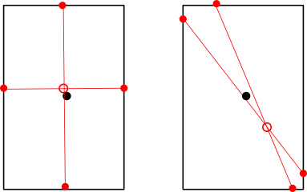
- tension
all these features are the result of the analysis of the lines joining the extreme vertical points an horizontal points.

